BREAKFAST CHATTER
Weekly Bulletin of Rotary Club of Kathmandu Mid-Town
District 3290 Volume No. 15/13 for #755 October 8 2004
www.rotarymidtown.org.np
OCTOBER IS VOCATIONAL SERVICE MONTH

SUNSHINE ANNOUNCEMENT FOR THE WEEK OF 08 October 2004;
Thanks for the ☺ Sunshine ☺ to Pratima, spouse of Gopal Kakshapati
****************

MEETING ACTIVITIES:

DATE | ACTIVITY | SUBJECT
08 OCT | Departing Rtn. Dr. Robert Scott | A Retrospective on 9.5 Years in Nepal
15 OCT | David Sowerwine | Building Bridges in Nepal
22 OCT | Dasain Holiday | Off- Everyone Work for Peace
29 OCT | Shyam Nepali | All about Sarangis (music included)

****************
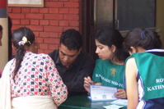
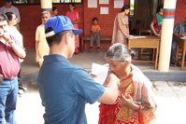
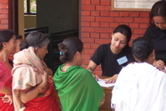
NEWS …….A fund is being raised to assist the Muslims who suffered during the riots. If you wish to contribute, Mr. Dahal will accept your donation.
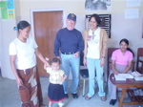
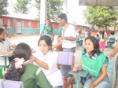
The Dental camps of this past weekend helped to raise awareness of the need for better hygiene among the clients. Scattered here are some of the participants at the lovely Mary Ward school in Lubu. Many many thanks are due to our hard-working Rotaract members, and to the efforts of our Rotarians.
In addition, Luke and Friends conducted a polio program at the Shanta Bhawan Clinic.
****************
THIS WEEK’S PRESENTATION BY ROBERT SCOTT:
This Friday is Robert Scott’s last stand (at least at the podium). Of course if he leaves like Robin Bradshaw, he’ll return by December! Robert will be speaking entirely off the cuff in a retrospective over the years he has served in Nepal, with Rotary, and with countless friends.
**************** YIR…David

